## horizontal line

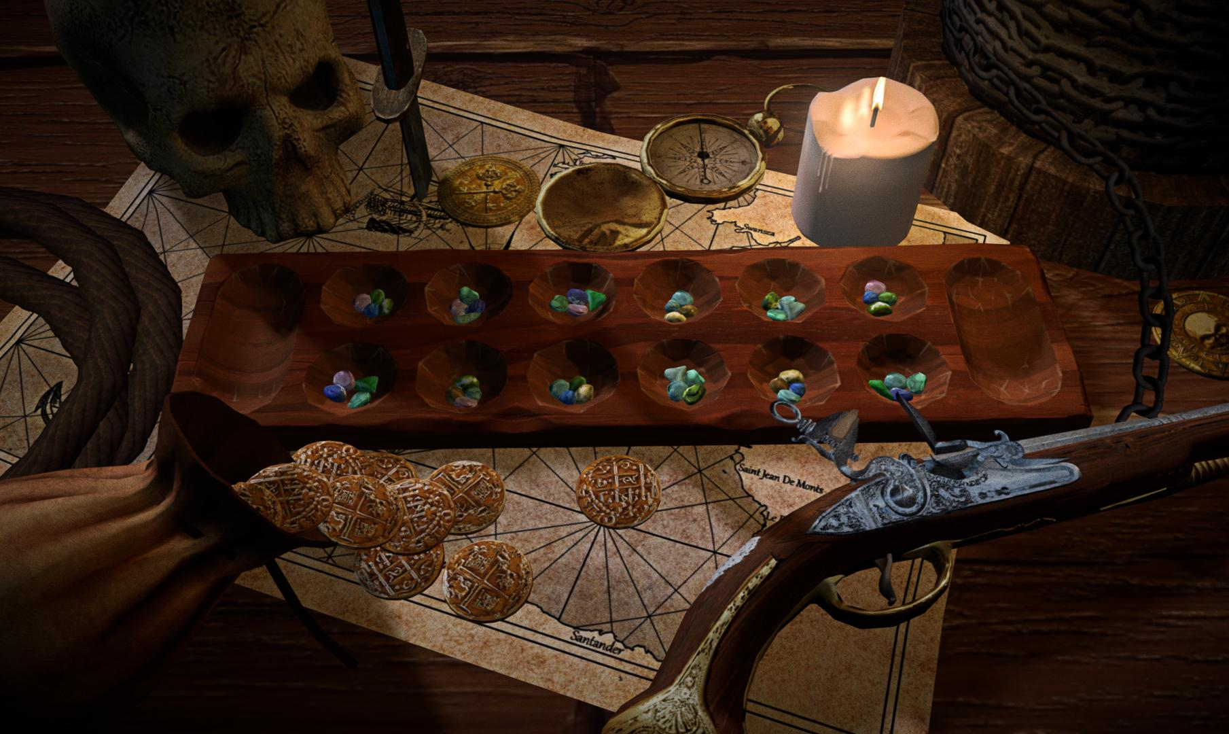

Plunder Design Document

Mancala Board Game

08.26.2017

**─**

Alan Mitchell

Untitled - Company Name Unkown

14001 N 48th ave

Glendale, AZ 85306

# Overview

Genre: Board Game

Target Audience: Casual / Social age range will be anyone who loves the mancala game or anyone wanting to play. M/F age range from 40 - 3 will lend itself to a younger audience with it’s pirate aesthetic.

Cost of time to develop: 3 months, 8 months with marketing plan.

# Goals

1. To release a free mancala board game and to create a port for playtable, ios, android. With AI and two player using same tablet.
2. Use advertisements to generate revenue and release an ad free game for 99 cents.
3. (optional) Turn based multiplayer over online connection.
4. (optional) Friends list ability for create a room or find other players over a network.
5. (optional) Creating a chat box allowing players to chat with each other.

# Specifications

Using the 3d engine unity we will optimize texture, script, 3d models, sound, sound files for ios and andriod and a seamless experience all around.

## Optimization

There is no real way to figure optimization other than getting it loaded and trying it. The goal is 1 real time light, highest resolution textures possible, highest sound quality with overlapping music, ambient, and voices (optional). Coin dynamic objects to flick around the screen (optional). Particle effects and camera movement when applicable such as in the cabin on the ship mimicking the uneasy feel as when on a ship (optional). All of these options must be toggleable in the options menu.

# Plunder Mode

## Varying Gameplay

Plunder Mode is a mode where half of the opposing cups are covered. You can see/see thru to your side of the table. This will change gameplay for veteran players of the game. May be unlocked after beating normal AI bot in gameplay. You can also choose the number of starting gems that appear in all cups.

# Milestones

## Prototype

Get a running version of the game with UI elements incorporated with test code.

## UI

Get a running UI and working properly with the correct scenes associated.

## Music/ Ambient Noise

Make music and ambient music files looped keeping in mind file size as much as possible.

## (optional) Animated Camera

Create and move a camera to be moving in a natural way in the the appropriate spots. Aka moving in an arch like pattern on the ship that feels close to a ship's movements in real life.

## (optional) Animated Stones

Create a highlighted track using code of the path the stones will travel ending where the last stone will be placed.

## (optional) Artwork for Player Busts

New artwork needs to be created as far as player avatars. Specifications are that all the art need to appear like it can appear in the same world. As each other and for the game

## (optional) Artwork Musket Balls

As a variation for the gems we could use musket balls as a quick replacement mesh.

## Finalize Artwork

All artwork has been finalized and been run through the appropriate programs.

## Finalize Animations

All animations meaning mainly camera movements and movements for stones

## Finalize code for AI Bot game

Finalize code for game cut out the fluff. Optimize optimize optimize!

## (optional) Add Dynamic Objects

Add either interactable objects or dynamic objects to the game ((example) flicking a gold coin across the screen. Turning the phone and a rotation by the compass, Optimized geometry to keep the game running smoothly.)

## (optional) AI Bot play/2 modes of play

Manipulate script for a wider variety of movements and maybe removing some of the elements the bot sees. See plunder mode.

## (optional) Multiplayer

Get the multiplayer up and running with a friends list or lobby system.

# User Interface

## Options Upon Starting Game

## Start New Game

## Continue AI

(Appears only if there was a previously played game Greyed out if there isn’t a preloaded game)

## (optional) Continue Online

(Appears only if there was a previously played game Greyed out if there isn’t a preloaded game or been kicked out of an online game)

## 

## 

## 

## Options (Opens the Options Menu)

## Start New Game

Pop Up Screen

## Single Player (Starts a new game AI opponent)

## Two Player (Starts a new game Local Opponent)

## Start New Online Game (Starts a new game)

## Pop up window pick the number of stones that appear in the cups 3 - 4 - 5

## 

## Online Game

Start New Game

Continue Game

## Start New Game

Search Random

Friends List

Add Friend

## Level

Pick a level

Captain Quarters 

Stranded 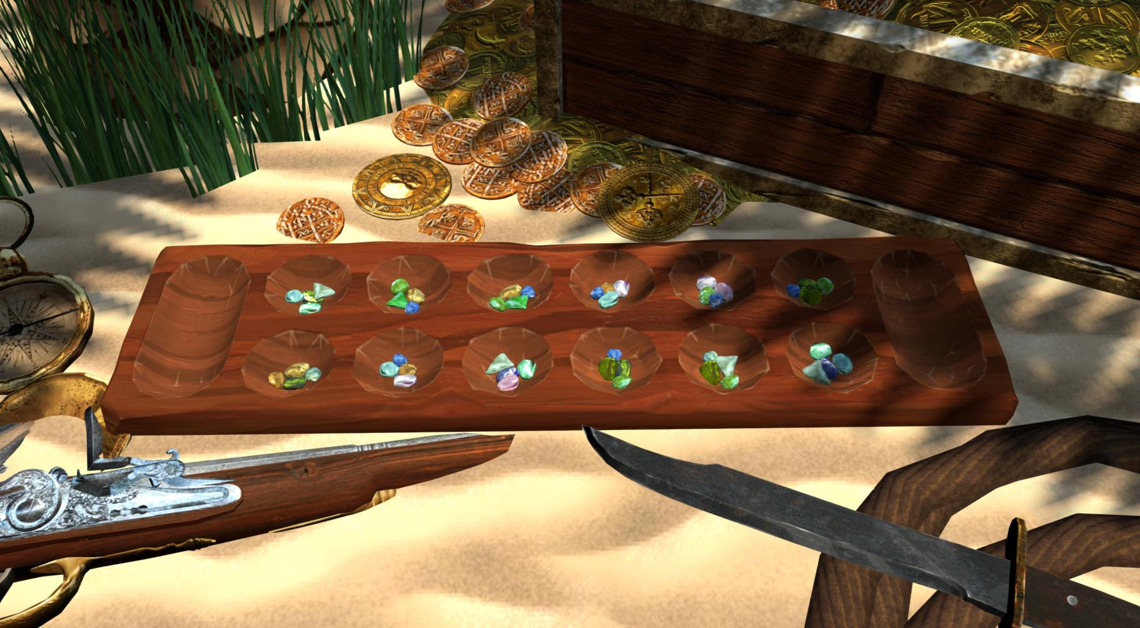

## Quit (Exits out of the game/application)

## Options

## Graphics Settings (controls graphics settings)

## Audio Settings (controls audio settings)

## (optional) Camera (toggleable) [controls animated camera]

## How To Play (explanation of how to play for new or novice players.)

## Credits

## Graphics Settings

## Resolution

Screen resolution settings

## UI elements

Busts

Color overlays for making a move

Gem counter for selected box

Show previous move (multiplayer setting)

Type of gem (optional)

1. Seaglass
2. Musket Ball
3. Bone

## Audio Settings

## Music

Slider from Low to High and Mute button

## Ambient Sounds

Slider from Low to High and Mute Button

## (optional) Background Voices

Slider from Low to High and Mute Button

Toggleable

## How to Play

The Goal of the game is to get the most gems inside your mancala which is the long oval at the end of each side. The cups on your side of the table you control when it is your turn. You select a up and pick up the gems inside this determines how many spaces you are moving counter clockwise. You drop a gem off in each sequential cup continuing to the mancala treating it as cup and continuing onto the opponent's side finally stopping when you have no more gems keeping in mind you will not score inside the opponent's mancala even if you were to reach the opponent's mancala instead you skip it. If the last gem lands inside your mancala you receive a second turn skipping your opponent's turn until your last gem doesn’t land in your mancala. If you have an empty cup on either side of the board and the last gem lands inside the empty cup if there are gems directly adjacent on the opponent's side or alternatively on your side when you are playing on the opponent's side collect gems from both sides and move them to your mancala, your turn is over.

## End States

The game ends when one side of the table can’t make anymore turns ending just after the one side who can play, player's turn is over.

## Win States

You win when your mancala has more gems than your opponent's mancala, and the game is over.

## Lose Sates

You lose when your mancala has less gems than your opponent's mancala, and the game is over.

## Tie State

You Tie when your mancala has the same amount of gems than your opponent's mancala, and the game is over.

## (Optional) Multiplayer

Upon entering a multiplayer match there needs to be some key functions.

## Chat box

Greyed out chat box in corner of screen showing last 3 messages when selected will pop up ios chat box displaying messages and scroll bar.

## Opposing players Displayed Name and Avatar

This will show players displayed avatar

Underneath avatar will be the player’s name

## Last Move

Mancala probably will not be played real time but as a series of updated states. Showing the player's last move will be key to deciding upon a strategy which is why upon opening the screen it will show the opponent's last move. Also a key feature may be a show last move button. With most likely a refresh button icon next to it. To help track what your opponent was able to do on their whole move.

## Art Style



The art style is a realistic interpretation of the pirates world with a slightly stylised look to it. We are selling the world the pirates lived in not the high adventures but the spaces in between, times you are playing on the floor in the cots. In the jail, lots of browns and muted colors with the highlighted colors used to bring interest to the table being greens and yellows. Using lights we will try to light each scene that maintains that realistic look but using complimentary colors to bring interest into the scene. The style of the characters must reinforce this same look rough and tumble characters but leaning a little more to reality using those same browns but using more color to add interest. Sickly or wretchedly skinny is the norm, Disease ridden pirates is what we are aiming to achieve. Nice or good looking pirates are rare and we want to make sure the player works to get those characters because they are so uncommon. Minimum amount of characters should be four. With at least one female.

Appended: Player Character is going to be represented by a cameo either logo or character.

Example: 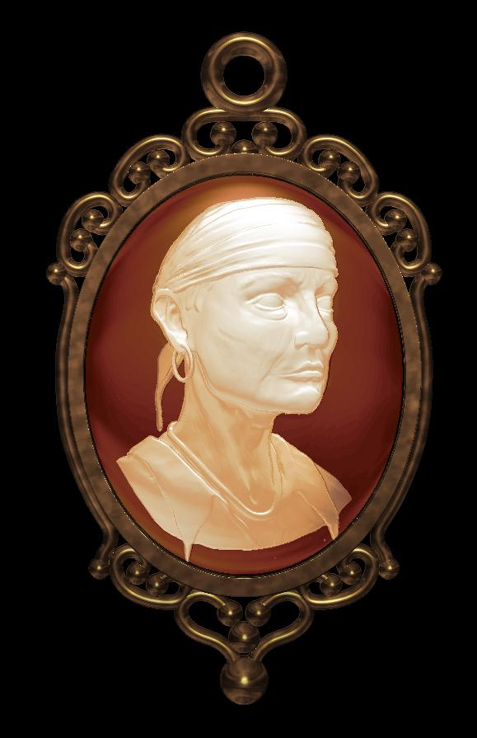

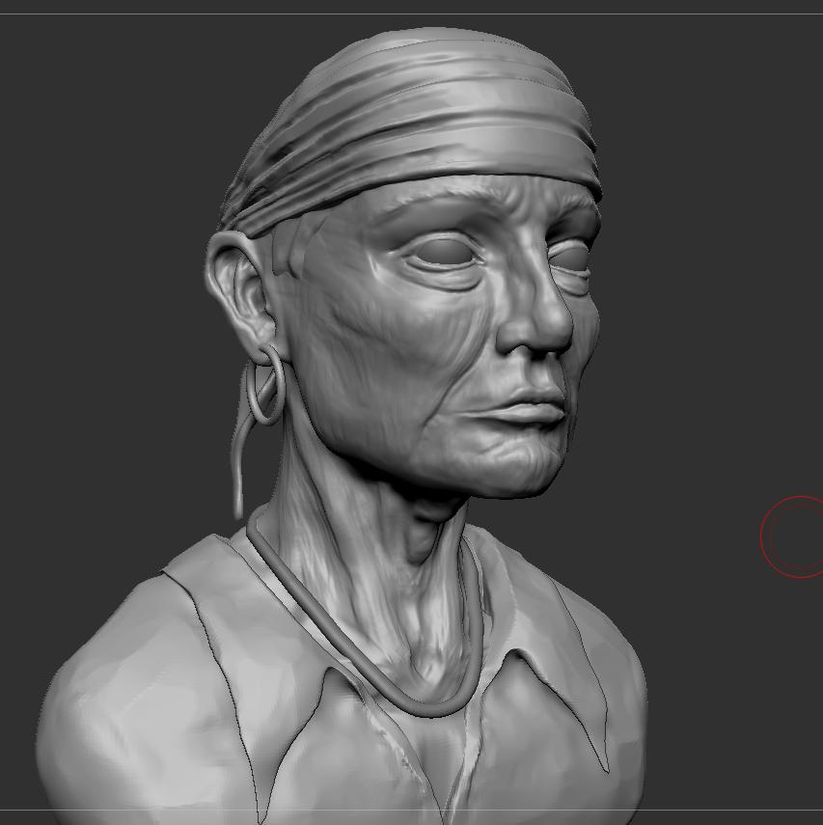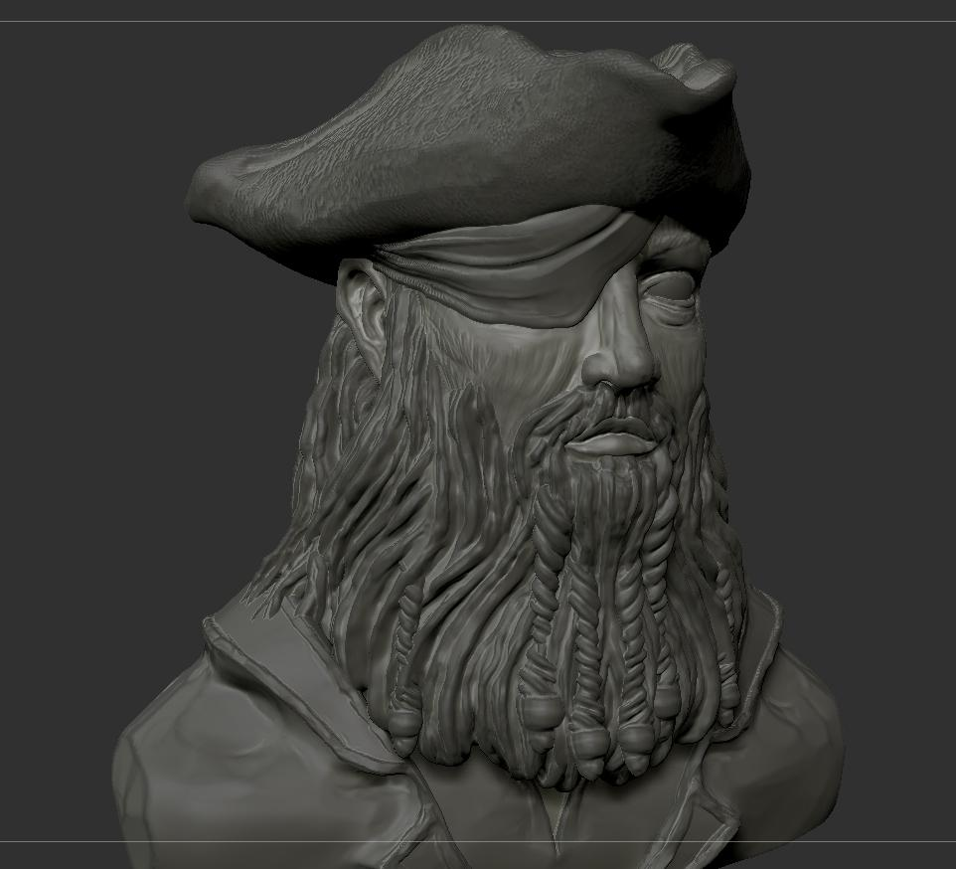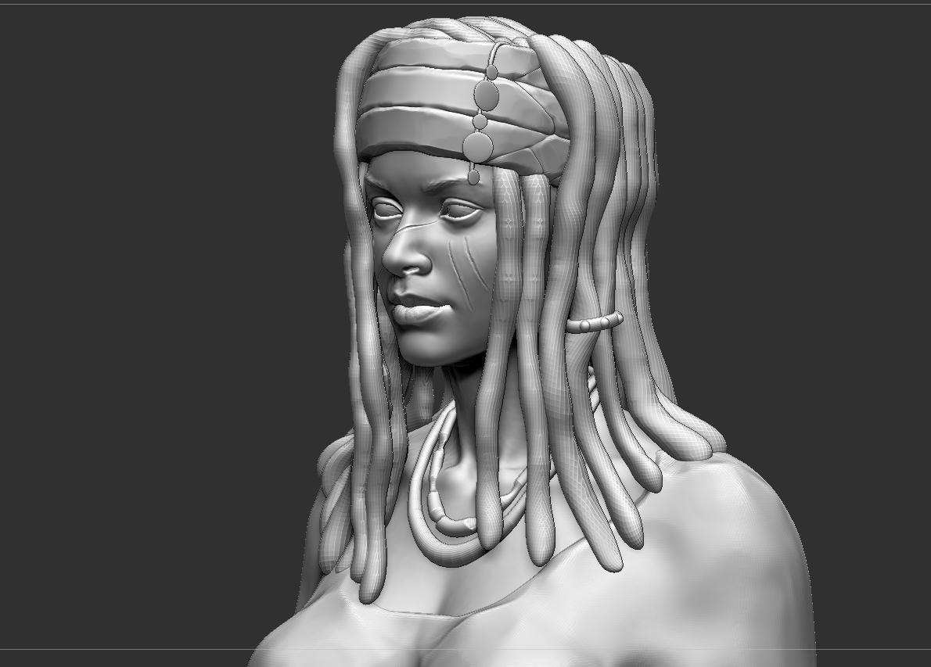

# Sound Design

## (optional) Voice Actors (Chicago)

The game needs to reinforce the idea of the pirates life with a playful tone. Characters talking to each other in the background is going to be one of our key features to bring the game to life.

## Ambient Sounds

Should convey the feeling of being on a ship aka scene_01, and the sound of being stranded on a beach aka scene_02 maintaining realistic sounds. Ship level we need creaking wood, wind ambient noise, and wave sounds all small looping sequences. Beach scene we need ocean waves, wind through trees, and seagulls

File Size for everything should equal out to about 38mb